1. Introduction
• Project Title: SMART SORTING : Transfer Learning For Identifiying Rotten Fruits And Vegebables

• Team Members:
- Byreddy Silpa Reddy
- Marchireddy Jahnavi
- Batthula Sravani
- Yaparala Venkata Lakshmi Thanmai

2. Project Overview
• Purpose: The primary purpose of smart sorting is to automate and optimize the process of separating items based on specific criteria, most notably in waste management to increase recycling rates and reduce landfill waste by accurately segregating materials like plastics, paper, and metals, but also in industrial processes for quality control and efficiency.
Features:
- AI and Machine Learning
- Advanced Sensors and Camera
- Automated Segregation and Automation
- Increased Productivity and Efficiency
- Enhanced Quality Control and Traceabilityx
- Dynamic and Adaptive Capabilities
- Quantitative Analysis and Data Insights
- Cost Savings
3.Architecture

The architecture of a smart sorting system for identifying rotten fruits and vegetables using transfer learning typically involves a Convolutional Neural Network (CNN) pre-trained on a large dataset, which then uses its learned features to classify images of produce as fresh or rotten. This process leverages the power of existing deep learning models to reduce the need for extensive custom training data and computational resources, allowing for efficient and accurate quality assessment.

Architecture Diagram: [Please insert architecture diagram image manually here]
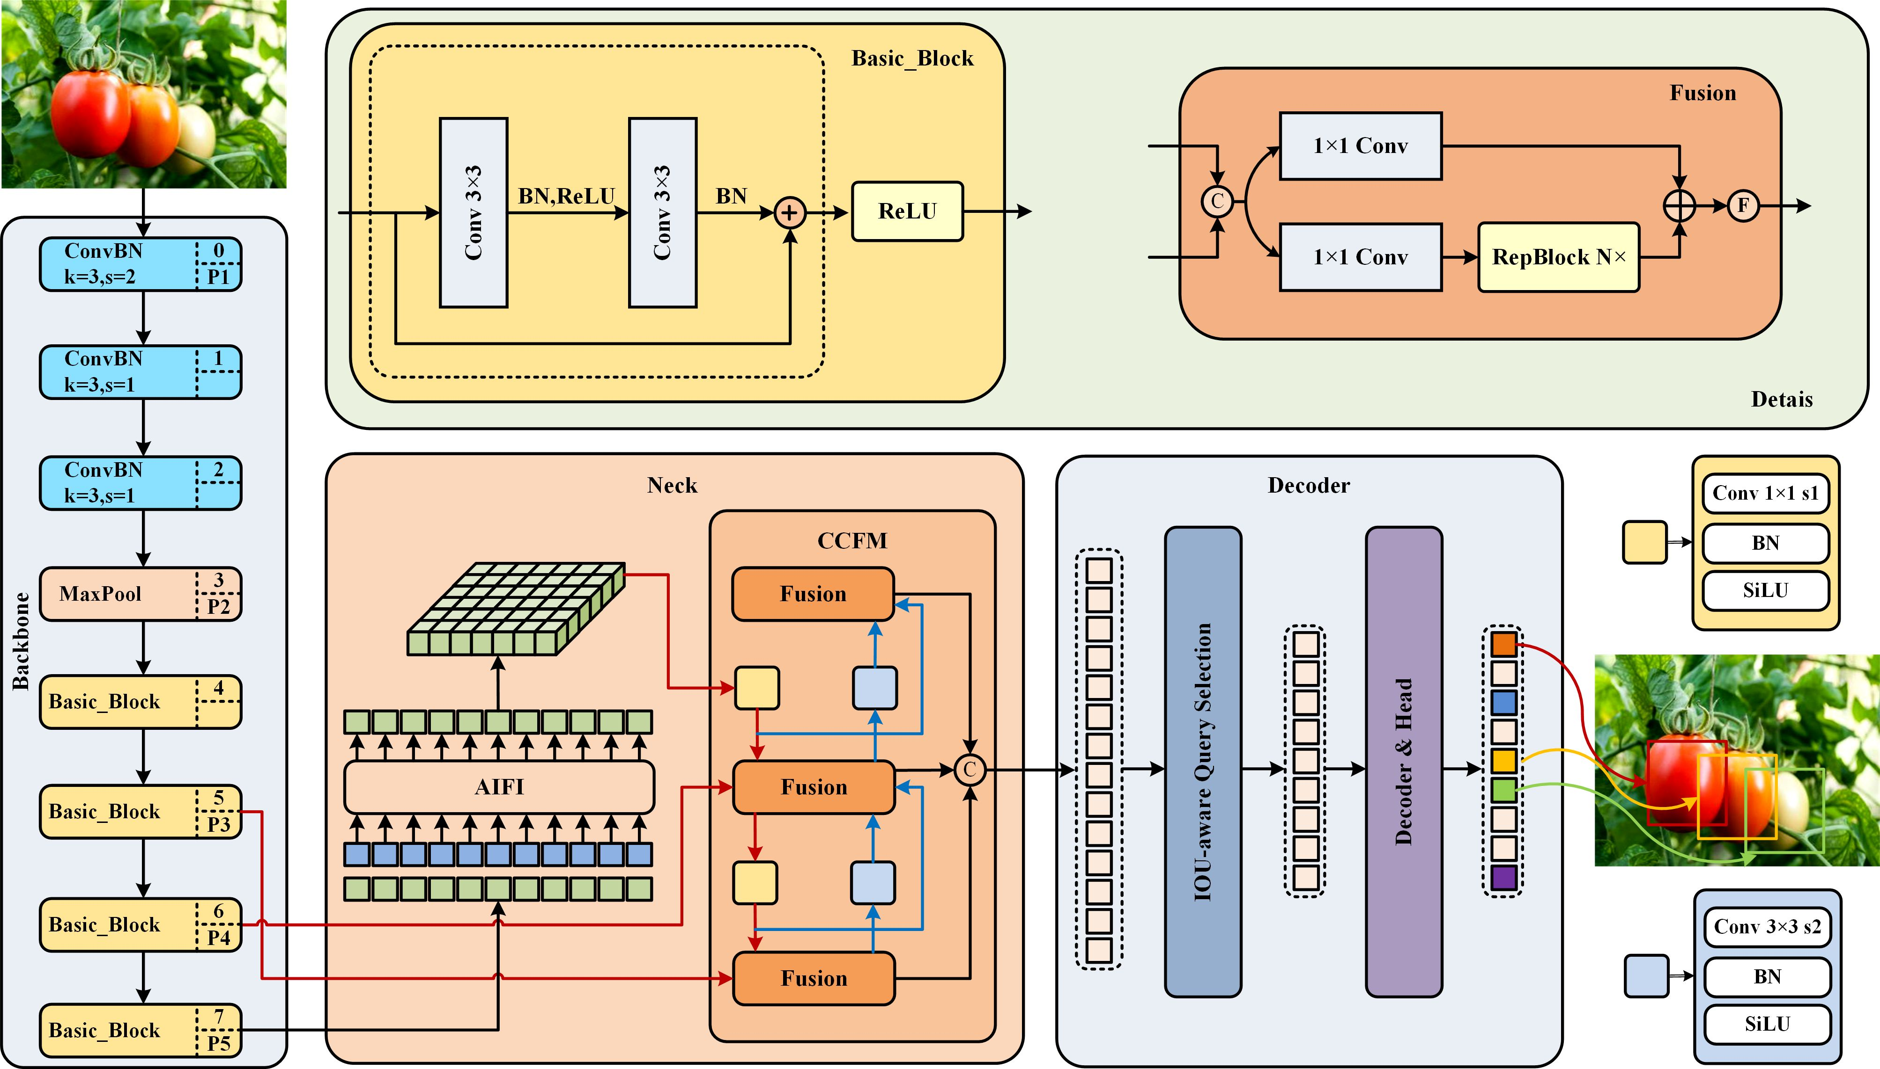

3. Instructions Setup
Smart sorting using transfer learning for identifying rotten fruits and vegetables powerful application of deep learning. Here are the key instructions and steps to take:
1. Data Collection and Preparation
Gather a diverse dataset of both fresh and rotten fruit/vegetable images. Ensure variety in lighting, backgrounds, and spoilage stages. Crucially, use data augmentation (e.g., rotation, flipping, zooming) to expand your dataset.
2. Choose a Pre-trained Model
Select a pre-trained Convolutional Neural Network (CNN) model, such as ResNet, Inception, or MobileNet. These models have already learned powerful image features from vast datasets like ImageNet, which is a great starting point for your task.
3. Model Adaptation (Transfer Learning Strategy)
Load the pre-trained model but remove its original top (classification) layer. Then, freeze the weights of the base layers of this pre-trained model; this means you'll only train the new layers you add. Attach new classification layers (e.g., Global Average Pooling, Dense layers, and a final output layer with a softmax or sigmoid activation) to the frozen base.
4. Model Training (Fine-tuning)
Compile your adapted model with an appropriate optimizer (e.g., Adam) and loss function (e.g., categorical crossentropy). First, train the model for a few epochs with the base layers frozen to quickly train your new classification head.
5 . Model Evaluation and Deployment
Evaluate your trained model on a separate, unseen test set to assess its accuracy, precision, recall, and F1-score. Once satisfied, integrate the model into a smart sorting system. This typically involves using cameras to capture images on a conveyor belt, running the model for real-time predictions (possibly on an edge device), and then using robotics or other actuators to sort the produce based on the model's output
5. Folder Structure

smart_sorting_rotten_produce/

|├── data/

│ ├── raw/

│ │ ├── apple_fresh/

│ │ ├── apple_rotten/

│ │ ├── banana_fresh/

│ │ ├── banana_rotten/

│ │ └── ... (other fruit/vegetable types, fresh/rotten)

│ │

│ ├── processed/

│ │ ├── train/

│ │ │ ├── apple_fresh/

│ │ │ ├── apple_rotten/

│ │ │ └── ...

│ │ ├── validation/

│ │ │ ├── apple_fresh/

│ │ │ ├── apple_rotten/

│ │ │ └── ...

│ │ └── test/

│ │ ├── apple_fresh/

│ │ ├── apple_rotten/

│ │ └── ...

│ │

│ └── external/

│ └── <any_downloaded_datasets_unprocessed>/

│ └── fruit_dataset_kaggle/

│ ├── Fresh/

│ └── Rotten/

│

├── models/

│ ├── saved_models/

│ │ ├── best_model_resnet50.h5

│ │ ├── latest_checkpoint.keras

│ │ └── training_history.csv (or a folder for each training run)

│ │

│ └── pre_trained/

│ ├── resnet50_weights_tf_dim_ordering_tf_kernels_notop.h5

│ └── inceptionv3_weights_tf_dim_ordering_tf_kernels_notop.h5

│

├── notebooks/

│ ├── 01_data_exploration_and_preprocessing.ipynb

│ ├── 02_model_training_transfer_learning.ipynb

│ ├── 03_model_evaluation.ipynb

│ └── 04_inference_testing.ipynb

│

├── src/

│ ├── data_loader.py (Functions for loading and augmenting data)

│ ├── model_builder.py (Functions for creating and adapting models)

│ ├── train.py (Script for training the model)

│ ├── predict.py (Script for running inference on new images)

│ └── utils.py (Helper functions like plotting, metrics)

│

├── requirements.txt (List of Python dependencies)

├── README.md (Project description, setup, usage instructions)

└── config.py (Configuration settings: image size, batch size, learning rate,paths.)

6.Running the Application

o "run" your smart sorting application:
* Set up:
* Install Python and create a virtual environment.
* Install dependencies: pip install -r requirements.txt.
* Ensure your processed data is in data/processed/.
* Train Model:
python src/train.py

This script trains the model and saves it to models/saved_models/.
* Evaluate Model:
python src/predict.py --mode evaluate --model_path models/saved_models/best_model_resnet50.h5 --test_data_path data/processed/test

Checks model performance on test data.
* Make Predictions:
python src/predict.py --mode inference --model_path models/saved_models/best_model_resnet50.h5 --image_path path/to/your/new_image.jpg

Classifies a new image (e.g., "apple_rotten").
This covers the essential steps from training to making real-time predictions.
7 . API Documentation
To "run" your smart sorting application:
* Set up:
* Install Python and create a virtual environment.
* Install dependencies: pip install -r requirements.txt.
* Ensure your processed data is in data/processed/.
* Train Model:
python src/train.py

This script trains the model and saves it to models/saved_models/.
* Evaluate Model:
python src/predict.py --mode evaluate --model_path models/saved_models/best_model_resnet50.h5 --test_data_path data/processed/test

Checks model performance on test data.
* Make Predictions:
python src/predict.py --mode inference --model_path models/saved_models/best_model_resnet50.h5 --image_path path/to/your/new_image.jpg

Classifies a new image (e.g., "apple_rotten").
This covers the essential steps from training to making real-time predictions.
8. Authentication
Okay, let's break down authentication for your smart sorting application with a medium level of detail, covering the main scenarios.
Authentication for Smart Sorting Application
Authentication is essential for securing access to your application's resources, data, and functionalities, especially as it scales beyond local development. Here are the primary areas where authentication applies:
1. Cloud Resource Access (Data Storage & Compute)
If your training data, pre-trained models, or compute resources (like GPUs for training) are hosted on cloud platforms (AWS, Google Cloud, Azure), your application needs to authenticate with these services.
* Methods:
* Environment Variables: The most common and flexible method for local development and initial deployments. You set cloud-specific access keys (e.g., AWS_ACCESS_KEY_ID, GOOGLE_APPLICATION_CREDENTIALS) in your shell environment before running your Python scripts. Cloud SDKs (like boto3 for AWS or google-cloud-storage for GCP) automatically pick these up.
* IAM Roles/Service Accounts (Recommended for Cloud Deployments): When deploying your application to a cloud VM or container service, you assign an Identity and Access Management (IAM) role or a Service Account to the compute instance. This grants the instance specific permissions to access other cloud services without hardcoding or exposing explicit credentials within your application code. This is a more secure and scalable approach for production.
2. Secure Access to Internal Data Sources
If your raw image data (data/raw) is stored on a secure internal server, network drive, or a private database, your data loading scripts (src/data_loader.py) will need authentication.
* Methods:
* Configuration Files (Excluded from Version Control): Store sensitive credentials (e.g., database usernames/passwords, API keys for internal data services) in a dedicated configuration file (e.g., credentials.ini or secrets.json) that is explicitly excluded from your version control system (e.g., via .gitignore). Your script reads these at runtime.
* Environment Variables: Similar to cloud access, sensitive connection strings or keys can be passed as environment variables to the scripts.
* SSH Keys: For secure file transfers (e.g., using SCP or SFTP) from internal file servers, SSH keys provide robust, password-less authentication.
3. Web Service / API Authentication (if predict.py is exposed)
If you decide to expose the prediction functionality of src/predict.py as a web API (e.g., using Flask, FastAPI, or Django) so other applications can request predictions, you'll need to authenticate those incoming requests.
* Methods:
* API Keys: The simplest common method. Clients include a unique API key in their request (e.g., in an X-API-Key HTTP header or as a query parameter). Your API endpoint then validates this key against a list of valid, securely stored keys.
* Implementation: Requires a middleware or decorator in your web framework that intercepts requests, checks the key, and allows/denies access.
* JSON Web Tokens (JWTs): More robust for scenarios involving user accounts or single sign-on. A client first authenticates (e.g., with username/password) to an authentication server, receives a JWT, and then includes this token in subsequent requests. Your API verifies the token's signature and expiration.
* OAuth 2.0: For complex scenarios involving third-party applications or delegated authorization.
* Key Security Considerations for Web APIs:
* HTTPS/TLS: Always use SSL/TLS encryption for all API communication to protect credentials and data in transit.
* Rate Limiting: Protect your API from abuse by limiting the number of requests a client can make in a given period.
* Input Validation: Thoroughly validate all incoming API inputs to prevent injection attacks and ensure data integrity.
General Authentication Principles:
* Never Hardcode Credentials: Store sensitive information securely outside your main codebase.
* Principle of Least Privilege: Grant only the minimum necessary permissions to any user, service account, or API key.
* Secrets Management: For production, consider dedicated secret management services (e.g., AWS Secrets Manager, Google Secret Manager, HashiCorp Vault) to centrally store, manage, and rotate credentials.
* Audit Logging: Log authentication attempts (success and failure) for security monitoring.
9. User Interface
A user interface (UI) for a smart sorting system (like the one for identifying rotten fruits and vegetables) is critical for operators to monitor, control, and understand the system's performance. It typically focuses on real-time feedback, monitoring, configuration, and data visualization.
Here are the key UI components for a smart sorting application:
User Interface (UI) Components for Smart Sorting
1. Real-time Monitoring Dashboard
* Live Camera Feed(s): Display of the current view from the sorting line cameras.This allows operators to visually confirm what the system is "seeing."
* Item Count & Throughput: Real-time display of items processed, sorted per category (e.g., "Fresh," "Rotten"), and sorting speed (items per minute).
* Prediction Confidence Indicator: For each item being processed, a visual indicator (e.g., a progress bar, color coding, or numerical score) showing the AI model's confidence in its classification.
* Current Item Status: Display of the most recently processed item, its predicted class, and confidence score.
* Error/Alert Log: A scrolling log or section for displaying system errors, hardware malfunctions, or instances where the AI model's confidence was low.
2. Configuration & Control Panel
* Start/Stop/Pause Buttons: Essential controls for initiating, halting, or temporarily pausing the sorting process.
* System Mode Selection: Toggles or dropdowns to switch between operating modes (e.g., "Automated Sorting," "Manual Review," "Calibration Mode").
* Sorting Rule Configuration:
* Threshold Sliders/Inputs: For adjusting the AI model's confidence threshold for classification (e.g., "Only classify as 'rotten' if confidence > 90%").
* Destination Mapping: Define which predicted class goes to which physical bin or conveyor.
* Recipe/Product Selection: If sorting different types of produce, allow operators to select the current product being sorted (e.g., "Apples," "Bananas").
* Hardware Settings: (Limited access for operators, more for maintenance) Controls for camera settings (brightness, contrast), conveyor speed, or actuator calibration.
3. Performance & Analytics View
* Historical Performance Charts: Graphs showing trends over time for:
* Daily/Hourly Throughput
* Accuracy (if a ground truth comparison is available)
* Ratio of Fresh vs. Rotten items sorted
* False Positive/False Negative rates (if quality control data is fed back).
* Quality Control Feedback Loop:
* Review Queue: A section where operators can review images of items that the AI had low confidence in, or items that were manually flagged for inspection.
* Correction/Recalibration: Buttons or forms to correct misclassifications, with the ability to "feedback" this correction to potentially retrain/fine-tune the model.
* Anomaly Detection: Visualization of data points that deviate significantly from the norm, potentially indicating a problem with the produce batch or the system itself.
4. Visual Inspection & Debugging Tools
* Image Gallery of Sorted Items: A browsable gallery of recently sorted images, categorized by their AI prediction.
* Detailed Image View: Clicking on an image displays it larger, potentially with:
* Bounding Boxes/Masks: Highlighted areas identified by the AI (e.g., a detected bruise or mold spot).
* Feature Overlays: Visualizations of what features the AI model focused on for its decision (using interpretability techniques like CAM, SHAP).
* Metadata: Timestamps, confidence scores, original prediction, and any manual overrides.
* Search/Filter: Ability to search historical data by date, class, confidence, or specific item ID.
5. User Management & System Status
* Login/Logout: For user authentication and role-based access.
* User Roles: Different interfaces or access levels for operators, supervisors, and administrators.
* System Health Indicators: Lights or status messages for critical components (e.g., "Camera Online," "Processor Status: OK," "Actuator 1: Active").
* Notification System: Pop-up alerts or email/SMS notifications for critical errors or low-confidence predictions requiring human intervention.
Key UI/UX Design Principles for Smart Sorting:
* Clarity & Simplicity: Information must be digestible at a glance, especially for real-time monitoring.
* Feedback & Responsiveness: The system must clearly indicate its status and respond promptly to user input.
* Error Prevention & Recovery: Design to minimize operator errors and provide clear paths to correct mistakes or recover from issues.
* Consistency: Maintain a consistent layout, terminology, and interaction patterns across all components.
* Efficiency: Streamline workflows, reduce unnecessary clicks, and prioritize the most important information.
* Visual Hierarchy: Use size, color, and placement to guide the operator's eye to the most critical information first.
* Accessibility: Ensure the interface is usable for all operators, considering factors like color blindness or touch screen interactions in an industrial environment.
The UI for a smart sorting system acts as the bridge between complex AI and automated hardware, empowering human operators to maintain quality control and troubleshoot effectively.

10.Testing
Strategies: Data validation,Model Perfomance,Robustness,Perfomance,End-to-
End,Regression.
Tools: Python Frameworks , ML Libraries , Monitoring.
11. Screenshots

Known Issues
- Data Quality & Quantity
- Model Performance & Robustness
-Hardware & Integration Challenges
-Operational & Economic Issues

Future Enhancements

Enhanced Food Safety and Waste Reduction:
Reduced Manual Labor and Time:
Feature Extraction and Classification:
Feature Extraction and Classification:
Improved Accuracy:
Leveraging Pre-trained Models:
Feature Usage Graph:
